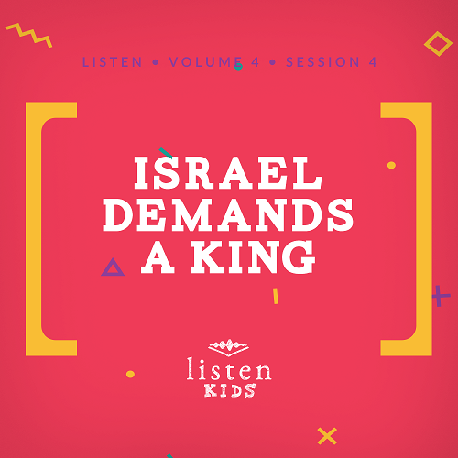Leader Overview
In Listen, kids will explore amazing truths from God’s Word, the Bible. In this session, kids will discover that they should decide, I will choose to follow God. God loves us. His desire is that all of us would follow Him as our King. He gave His Son for each of us that we would be in relationship with Him. Colossians says that God chose us to be the people He loves. Help the kids know that they were chosen by God for a purpose.

Bible Lesson
People Demand a King
1 Samuel 8:1–20
Faith Fact
I will choose to follow God.
Faith Verse
Isaiah 41:10 (NLT)
“Don’t be afraid, for I am with you. Don’t be discouraged, for I am your God. I will strengthen you and help you. I will hold you up with my victorious right hand.”

Preparing for the Session
Leader Preparation Time: 20–25 Minutes
You Will Need
Large Group
- Bible, one per kid
- Large Group Game, number to print is determined by the size of your group
- Worship songs (Song suggestions: “Real Love” by Hillsong Young & Free; “Chain Reaction” by River Valley Worship; “Good Good Father” by Chris Tomlin)
- For groups not using a phone or tablet only, add:
• Projector or TV
• Laptop
• Rules Video or Slide
• Countdown60 Video–60 seconds
• Faith Fact Slide
• Faith Verse Video or Slide
• Bible Lesson Video A
• Bible Lesson Video B
• Large Group Game
• Bible Lesson Slides 1–3
Small Group
- Small Group Group Connection, one per kid (two versions are available)
- Markers or crayons
- Small Group Faith Verse Review page
- Small Group Activity Page, one per kid
- Markers or crayons, one of the following colors per kid: blue, green, orange, purple, red, and yellow

To download session videos, slides, and printables, visit: BibleEngagementProject.com/downloads

Getting Ready
Large Group
- Download videos and slides if needed.
- Select worship song(s) and have them ready to play.
- Print the Large Group Game, as many donkeys as needed for your group.
- Cut apart the slips and hide the donkeys around the room.
Small Group
- Print copies of the Small Group Group Connection, one per kid.
- Print the Small Group Faith Verse Review page, one per group.
- Cut apart the slips of the Small Group Faith Verse Review page.
- Print copies of the Small Group Activity Page, one per kid.
- Gather the specific colors of markers or crayons.

First time leading Listen for Kids? Check out the Facilitator Guide.

Large Group
30 Minutes
See what’s needed at the beginning of the session.

Introduction
Wow! It’s great to see you today! You’re not here by accident. God knew that you were going to walk through the door and hang out with us today. He knows everything about you and He chooses you. That’s right, God chooses you! He knows the plans He has for you, and they are for you to choose to serve Him all of your life and to share His love with others.
Have you ever thought about what you are going to do for a job one day? What would you choose? (Allow response) Whatever that thing that God has planned for you to do, you can do it for Him, and with Him!
Today, we’re going to talk about a time when God had the job as King of Israel. He was a very good and fair King, but the people wanted to be like everybody else and have a man as their king. The man that God appointed was named Saul. He was just your average guy. Well, he wasn’t average in height because Saul was actually pretty tall and he was really handsome. That didn’t make him a better king than God. Israel made a big mistake to want a man to be their king instead of God. They should have chosen to follow God. Hey, that’s just like our Faith Fact for today!
• Show the Faith Fact Slide.
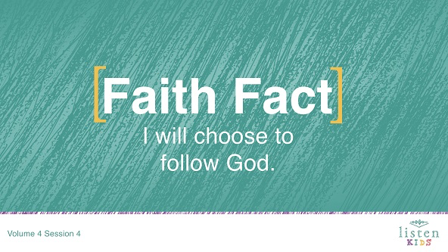
Let’s say it all together. I will choose to follow God. You’ll hear more about this as we go along today.
Rules Review (Optional)
Are you ready to have fun today? (Group response) I want to have fun, too. Before we get started, we need to make sure that we all know the rules.
• Play Rules Video.
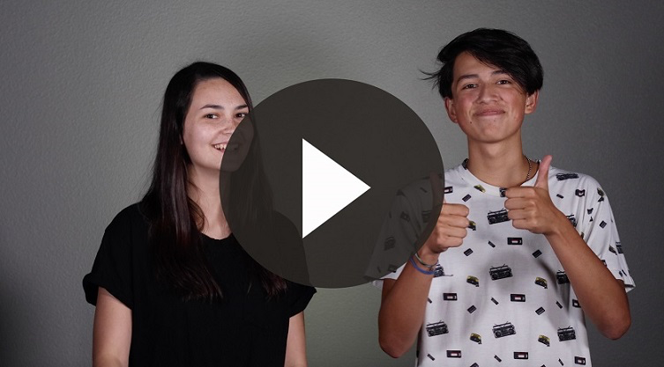

Game
Find the Donkeys
Now that we’ve talked about what we’re going to explore today, are you ready to play a game? Before we started today, I hid several pieces of paper with a donkey on them around the room. I am going to give your team one minute to find as many as you can. Here is the catch: only one person from your team can search at a time. When the first person finds a donkey, he or she returns to your team and tags another kid to go search. Remember to keep all the donkeys you find.
• Divide the group into teams.
• Play Countdown60 Video when you’re ready to start.
• Repeat until all donkeys are found.
That was so much fun searching for the donkeys. In today’s Bible story, we will discover what happened to the future king of Israel when he went to go find his lost donkey.

Worship
That was so much fun! Now, it’s time to sing our praise to God! Are you ready? Get on your feet. Here we go!
• Lead the kids in singing one or two praise songs. See suggestions at the beginning of the session.

Bible Lesson
Have you ever wondered if God really wants to be in relationship with you? I know I have. The best place to look to find the answer is in God’s Word, the Bible. (Hold up your Bible.) Let’s take a moment to pray and invite God to be with us.
Prayer
Dear God, thank You for being with us and believing in us. Help us to know You more as we learn from the Bible. We want to choose to follow You. Amen.
Video Intro
Before we get started hearing more from God’s Word, let’s check in with Dash and Austin and see what they’re up to. They always have a crazy challenge!
• Play Bible Lesson Video A.
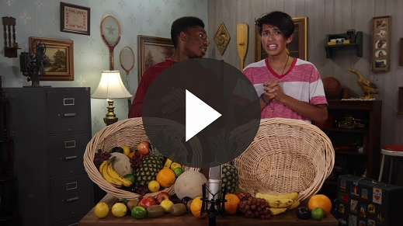
Oh, man! Today’s challenge doesn’t seem too hard to do. What do you think? (Group response) I wonder how the Fruit Follow challenge connects to our Bible story today.
Bible Story
(Open the Bible to 1 Samuel 8.) Let’s play Thumbs-Up, Thumbs-Down. I’m going to ask you questions as I tell the Bible story, and you will predict the answer. When I say, “Take your pick,” you need to decide thumbs-up for yes or thumbs-down for no.
• Have kids practice thumbs-up and thumbs-down.
Last time, we heard about Samuel. He was the boy who grew up in the tabernacle with Eli, the priest. As Samuel grew older, he became one of the judges for the people of Israel.
Do you think Samuel was a good judge for Israel? Take your pick!
• Thumbs-up for yes and thumbs-down for no. Give time for kids to choose.
Yes! Samuel was a great judge for Israel. Many people consider him one of Israel’s greatest judges.
In his old age, Samuel selected his sons to be judges over Israel. Do you think Samuel’s sons were good judges for Israel? Take your pick!
• Thumbs-up for yes and thumbs-down for no. Give time for kids to choose.
Nope, they weren’t! That was a problem; Samuel’s sons weren’t like him. They were greedy and found ways to cheat people out of money. Do you think the people of Israel wanted Samuel’s sons to be their judges? Take your pick!
• Thumbs-up for yes and thumbs-down for no. Give time for kids to choose.
That’s right! The people of Israel didn’t like what the sons were doing, so they called a meeting with Samuel. Let’s read what they said in 1 Samuel 8:5.
• Read 1 Samuel 8:5.
Until this time, Israel had no man or woman to rule their land. When God had chosen them as His people and brought them out of Egypt, He wanted to make them a special nation that was different from all of the other nations around them.
What are some ways that you think God wanted Israel to be different? (Allow responses.) Those are great answers! The main difference was going to be that Israel wouldn’t have a human king because God was going to be their King.
God wanted His people to follow Him and trust Him to take care of them just like a king would do. God had already provided so much for the Israelites. He had helped them escape danger, He had helped them conquer and take the Promised Land, and He had raised up judges to lead in difficult times. God was the best King that Israel could ever have.
Do you think the Israelites were happy with God as their King? Take your pick!
• Thumbs-up for yes and thumbs-down for no. Give time for kids to choose.
Even though they were in the best situation they could have been in, they still wanted to be like the other nations around them. They decided they wanted a human king.
• Show the Bible Lesson Slide 1.
Do you think Samuel was happy that the Israelites were demanding a king? Take your pick!
• Thumbs-up for yes and thumbs-down for no. Give time for kids to choose.
This didn’t please Samuel, and he talked to God about it to get advice. Let’s read what God said in 1 Samuel 8:7–9.
• Read 1 Samuel 8:7–9.
Do you think God was happy with the Israelites decision? Take your pick!
• Thumbs-up for yes and thumbs-down for no. Give time for kids to choose.
I think it made God sad that the Israelites rejected Him as their King. It also sounds like Israel was making a big mistake here, but God gave them what they wanted. God lets us make our own decisions, and He lets us make mistakes. Many times, that means we have to learn the hard way just like Israel.
Samuel went back to the people of Israel. Before He told them what God had said, he gave them one last warning about becoming like other nations. Samuel tried to tell them all about how a human king would treat them.
Let’s stand up and pretend we are all Israelites. Let’s act out some of the warnings that Samuel gave to God’s people.
Samuel said that a king would take their sons to run before his chariots. Everyone has to run in place for ten seconds.
• Have kids run in place for ten seconds.
Samuel also said that the king would make God’s people work hard in his fields. Let’s get on our knees and pretend to pull weeds from the ground.
• Have kids pretend to pull weeds for ten seconds.
Samuel also told them that the king would take their daughters to cook food for him. Let’s pretend to flip pancakes.
• Have kids pretend to flip pancakes.
Last, Samuel told them that the king would even take their flocks and cattle. Let me hear your best cow and donkey sounds.
• Have kids make cow and donkey sounds for ten seconds.
Even after hearing all of Samuel’s warnings, the people still said they wanted a king so they could be like the other nations. God allowed them to have a king, and He sent the man that He had chosen to be king to meet Samuel.
God told Samuel that he was going to meet a man from the land of Benjamin and that he was to anoint that man as king of Israel. Saul’s father had sent Saul to look for his lost donkeys. Saul went to see Samuel because he thought Samuel could help him find the donkeys. When Samuel saw Saul, God told him that this was the man He had chosen to be king.
Samuel told Saul that he wanted to eat dinner with Saul. In the morning Saul could go home. Saul thought he had come to see Samuel, but instead Samuel said that Saul had come because he and his family would be the focus of Israel’s hope. This was a big surprise to Saul.
• Show the Bible Lesson Slide 2.
Saul didn’t think he was anyone special. But God had plans for Saul, even if he didn’t think he was good enough to do them. The next morning, Samuel took olive oil and poured it over Saul’s head. He anointed Saul as king of Israel!
• Show the Bible Lesson Slide 3.
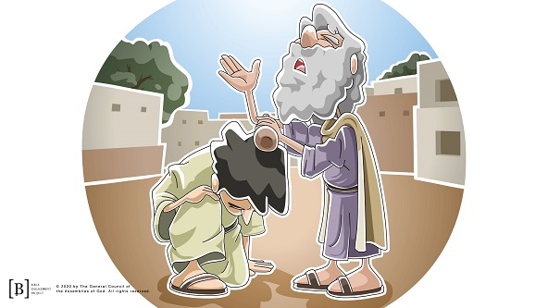
Teaching Time
Israel finally got the king they wanted, but it wasn’t the king they really needed. God was their one true King, but they had replaced Him so they could be just like other nations. King Saul started off good, but he soon disobeyed God and stopped leading Israel in a godly way.
Israel struggled to follow God faithfully, and they faced some terrible problems because of their decision to disobey Him. We can learn a lot from the way they lived. That’s why their story is told in the Bible. When I read this story, there is one thing I know: I will choose to follow God.
The decision to follow God is ours to make. No one can make that decision for you, but it will be the best choice you ever make. God wants a relationship with you just like He chose Israel to be His people. He will be with you wherever you go. He will help you in times of need. All you have to do is choose to follow Him.
We must be careful that we don’t get distracted by trying to be like the people around us. God wants those who follow Him to live differently from other people in the world. It’s easy for us to be like Israel and desire to be like those around us, who might be breaking rules or disobeying. The best thing for us is that we choose to follow God, and that means living differently.
Faith Verse
Let’s say our Faith Verse with the actions together.
• Play Faith Verse Video.
Isaiah 41:10 (NLT)
“Don’t be afraid, for I am with you. Don’t be discouraged, for I am your God. I will strengthen you and help you. I will hold you up with my victorious right hand.”

Prayer and Response
Consider playing a worship song softly in the background while kids pray.
Let’s take some time to pray and talk with God. God wants a relationship with you, but will you choose to follow Him? Let’s close our eyes, quiet ourselves, and talk to God about it.
• Give kids time to pray. Then introduce the worship song. This could play in the background while kids pray or could be a worship song to sing together.
Worship Song
Play a worship song. See suggestions at the beginning of the session.
Video Wrap-Up
Before we go to our Small Group activities, let’s see how Dash and Austin’s challenge worked out.
• Play Bible Lesson Video B.
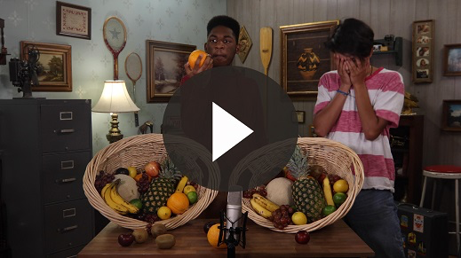
I love the way Dash and Austin challenge us to follow God. I’m ready to choose to follow God.
Let’s say our Faith Fact. I will choose to follow God. That was great! I knew you could do it. It’s been fun spending time together!
• Dismiss kids to Small Group time or to go home if your group time ends here.

Small Group
30 Minutes
This section can be done in conjunction with the large group, or on its own if you do small groups with your kids. During Small Group time, the goal is to connect the kids with the Word of God and to each other. All activities are led by the small group leader.

Group Connection
Word Search
You Will Need
- Small Group Group Connection, one per kid (two versions are available)
- Markers or crayon, one per kid
Getting Ready
- Print copies of the Small Group Group Connection, one per kid.

When the people of Israel demanded a king, Samuel went to meet the man God had chosen to be Israel’s first king—Saul. Today, each of you is going to complete this word search. Like Samuel searched for Saul, you get to search for words.
• Pass out the word search and markers or crayons.

Bible Lesson Recap
You Will Need
- Bible, one per kid

No prep is needed for this activity.

Bible Story Review: 1 Samuel 8:1–20
The people of Israel wanted to be like other nations. They wanted a man to be their king. God tried to warn them that this was not a good idea, but they didn’t want to listen. Let’s dig into God’s Word to read what happened.
• Divide the Bible reading into smaller chunks for volunteers to read aloud if needed.

Faith Fact
God chose Saul for an important role, and He has something important for you to do, too. Point to yourself and say the Faith Fact with me: I will choose to follow God.
• Show the Faith Fact Slide.
I will choose to follow God.

Group Discussion
Feel free to use all or just a few questions as a jumping-off place for good discussion. Questions marked with * are designed for more conversation. Adjust the questions based on the age or maturity of your group. Typically, older children will be able to dive a little deeper than younger ones.
Questions
Why do you think the Israelites wanted to have a human king?
Why do you think God allowed the Israelites to have a king even though God knew it wasn’t best for them?
Have you ever wanted to do something your way instead of God’s way?
How do you think Saul felt when he was told he would be the king of Israel?
Have you ever been asked to do something you didn’t feel confident to do?
* God knows everything about you and has chosen you to share His love with others. Do you think He has made a good choice? Why or why not?
* How would our lives look different if we did or didn’t choose to follow God?
* How can you use some of your abilities to serve God?
* How can you choose to follow God today?

Application and Response
Being obedient isn’t easy. Sometimes the things God asks us to do are hard or not much fun at all. In those times, we have a choice. We can go our own way, or we can do it God’s way. When we choose to do it God’s way, we are being faithful. God always rewards faithfulness. What should we do if we think doing it God’s way is too hard? We ask God for help. He may not make the task easier, but He will help strengthen and encourage us to complete it. You have an important part to play in God’s plan for this world. You’ll need His help to do what He asks. Remember, He has chosen you!
Does that remind you of our Faith Fact?
• Show the Faith Fact Slide.
Let’s say it all together: I will choose to follow God.
Make It a Habit
Select a simple visual reminder of the session’s Faith Fact.
Let’s use a visual reminder to help us remember what we’ve learned about God today. Let’s be creative just like our God is. Let’s come up with a way that we can remember to choose to follow God. For example, I could think about how I will choose to follow God every time I look at my Bible this week. What do you think we should use to remember our Faith Fact?
• Make notes of what the kids share.
Prayer
Let’s pray and ask God to help us.
Dear God, thank You that You have a plan and a purpose for me. Help me to choose to follow You every day. Amen.

Faith Verse Review
Our Faith Verse for today is Isaiah 41:10. It tells us that we don’t need to be afraid, that God is with us, and that He will help us. When we know God’s Word, He can bring a verse or Bible story to mind just when we need it.
Faith Verse Video Review
• Show the Faith Verse Slide.
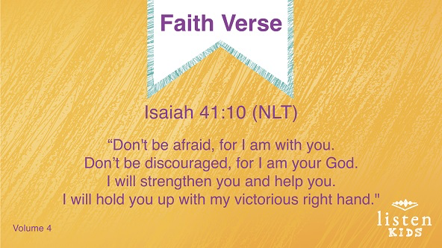
Isaiah 41:10 (NLT)
“Don’t be afraid, for I am with you. Don’t be discouraged, for I am your God. I will strengthen you and help you. I will hold you up with my victorious right hand.”
Let’s lock this verse in our hearts and minds, so that we always remember it!
• Repeat the verse several times. Get creative with the verse practice. Split the group up and have them compete. Try saying it in different voices or pitches. Ask individual kids to choose how to practice it. Have fun!
Faith Verse Fun
Word Scramble
You Will Need
• Small Group Faith Verse Review page
Getting Ready
• Print the Small Group Faith Verse Review page, one per group.
• Cut apart the slips.

Kids, I have a fun way to help us learn the Faith Verse, but I need your help. Let’s work together to put this verse in order. Once we have it lined up properly, we will recite our Faith Verse. Everybody take a slip and when I say, “Go,” we’ll see how quickly we can put the Faith Verse in order. Ready, set, go!
• Let kids choose a slip of the Faith Verse.
• Repeat as time allows.

Create Activity
You Will Need
- Small Group Activity Page, one per kid
- Markers or crayons, one of each of the following colors per kid: blue, green, orange, purple, red, yellow
Getting Ready
- Print the Small Group Activity Page, one per kid.

How many of you have done a color-by-number picture before? Today, we are going to follow the numbers to color this crown. What one thing would you do if you were crowned king or queen? (Allow responses.)
Prayer
Dear God, thank You for being patient with me when I make mistakes and fail to follow You. Help me to choose every day to follow You. Amen.

Faith Fact Recap
• Display the Faith Fact Slide as parents are coming into the room.
• Maximize the time you have with your kids so that parents see what their kids have learned. Have the kids repeat the Faith Fact and then dismiss them to their parents.
Today’s Faith Fact is really important. Following it every day will make a huge impact on our lives.
• Show the Faith Fact Slide.
Let’s say it together one last time: I will choose to follow God. That’s what I’m praying for you this week—that you will choose to follow God. See you!

Dismissal
• Send home the Small Group Activity Page and the Small Group Group Connection page with each kid.
• Remind parents that there are Family Devotions available on the app to do with their kid.
• Tell everyone the date and time for the next session.

